Exploratory Analysis Findings for Forecast Alignment
Prepared by: Exploratory Analysis Lead
For: Pipeline Lead
Dataset: northstar_clean.csv (2020-01-01 to 2022-06-30; 912 days per SKU; no missing values in units_sold)
Forecast split: Training through June 2, 2022; holdout June 3–30, 2022
Series in focus (all France | E-commerce | Home Storage): NS-003 (Asia-Suez), NS-033 (Regional-Europe), NS-048 (Air-or-Other)

Summary
All three series show a strong November–December peak, a smaller April–May bump, and a consistent weekly cycle with Saturday highest and Monday lowest. Most unusual spikes are explained by promotions or holidays. Stockouts are rare. The 2021 Suez blockage was a supply shock for NS-003 but did not reduce its sales. The holdout month is a quiet period with no holidays, few promotions, no stockouts, and normal transit times, so the forecast should be close to recent levels and should reproduce the weekly cycle.

1. Seasonality
All three SKUs follow the same yearly shape. Sales climb in November and peak in December at about 36–39% above their overall average. There is a smaller peak in April–May, and the low point is September–October. June is close to average, so no seasonal spike should be expected in the holdout.
- NS-003: 32.5 units/day in December vs 23.9 overall average
- NS-033: 20.2 units/day in December vs 14.8 overall average
- NS-048: 40.5 units/day in December vs 29.2 overall average

2. Weekly Pattern
Saturday sales are about 45–50% higher than Monday sales for all three SKUs, with a steady rise from Monday to Saturday. This is the easiest pattern to check in the forecast: a flat daily forecast with no weekly cycle has not captured it.

3. Trend
There is a mild upward trend. Average daily units from 2020 to 2021 to 2022 (January–June only):
- NS-003: 23.2 → 24.2 → 24.7
- NS-033: 14.2 → 15.1 → 15.5
- NS-048: 27.8 → 29.5 → 31.3 (strongest growth)
The trend is genuine, because 2022 is already higher even though its figures do not yet include the November–December peak.

4. Spikes and Drops
- Promotions: about +23–28% lift on promo days, excluding holidays (e.g., NS-003 rises from 22.9 to 29.3 units/day).
- Holidays (December 18 – January 3): about +40–48% lift.
- Of 11 statistically unusual spikes, 9 coincide with a promo or holiday flag. The two unexplained spikes are both NS-033: December 4, 2021 (39 units vs about 19 normal) and February 12, 2022 (33 units vs about 13 normal).
- No large unexplained drops were found.

5. Stockouts
Stockouts are rare, about 1% of days: 10 days for NS-003, 6 for NS-033, and 5 for NS-048. There are no stockouts in the holdout window.
On stockout days, units_sold equals exactly the opening inventory plus inbound units. This means stock ran out and true demand was higher than recorded (censored demand). These days slightly pull the training data down, but the effect is small because they are few.

6. Suez Blockage (March 2021)
For NS-003, the blockage was a supply shock, not a demand shock.
- Transit delay jumped from about 1.4 days to about 13 days in the week of March 28, 2021, and stayed elevated (4 days or more) until mid-May, about 7 weeks. The impact lasted much longer than the March 23–29 blockage itself.
- Opening inventory fell from about 160 to about 56 units, but there were no stockouts and sales did not drop. Sales were slightly higher, at about 26 units/day in April.
- For context, across the full dataset the Asia-Suez stockout rate rose from 0.72% to 2.89% during March 23 – May 15, 2021. Inventory buffered this France E-commerce SKU, even though other Asia-Suez series were affected.
- NS-033 (Regional-Europe) and NS-048 (Air-or-Other) were not affected.

7. Holdout Check (June 3–30, 2022)
SKU | Last 28 training days (May 6 – Jun 2) | Actual holdout (Jun 3 – 30) | Promo days (training / holdout)
NS-003 | 25.3 units/day | 26.5 units/day | 1 / 2
NS-033 | 17.2 units/day | 14.7 units/day | 4 / 1
NS-048 | 35.1 units/day | 33.3 units/day | 3 / 2

The holdout has no holidays, no stockouts, and normal transit delays. Points to check in the forecast:
- Weekly cycle: the Saturday peak and Monday low should be visible.
- Level: daily forecasts should be close to the actual holdout averages above.
- Possible overforecast for NS-033 and NS-048: the end of training had more promo days, which raised the late-May level. If the forecast runs high, this is the likely reason, not an error in the holdout data.
- No artificial dip: the model should not forecast a drop based on the 2021 Suez pattern, since that period had no demand drop.

8. Data Quality Notes
- 16 rows across the three series have missing values in non-target fields (unit price, marketing spend, opening inventory, supplier lead days, or transit delay). The target, units_sold, has no missing values.
- In the weekly chart, the first and last weeks look like sharp drops. These are partial weeks, not real declines in sales.

Figure
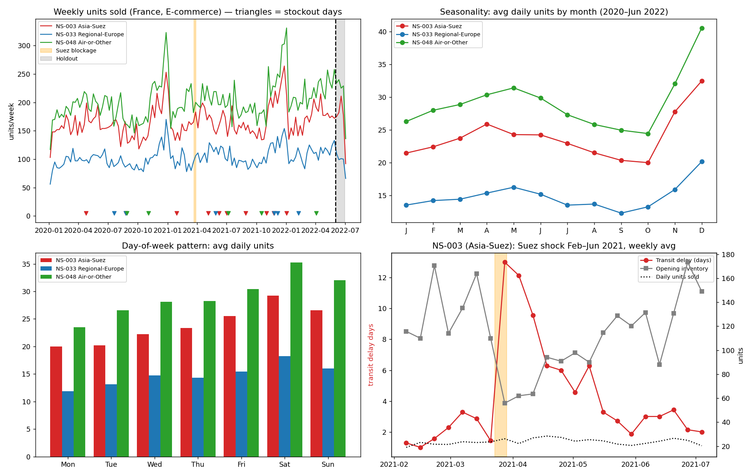
Figure 1. Weekly units sold with stockout days and holdout window; monthly seasonality; day-of-week pattern; NS-003 transit delay and inventory during the Suez disruption.

